Reporting No:1 Week No:3 From :11/05/2024 To :15/05/2024 College ID: 22AIML012

Project Title: student collage recommendation system

**WEEKLY REPORT**

**Work done in last week ( Attach supporting Documents):**

1. Make a ai generate promt.

2. write a program of besic ai picture generate prompt.

3. use library from python.

4. find a suitable output for that program.

**Reason for incomplete work:**

1. watch video and blog how to generate a ai picture using prompt.

**Plans for next week:**

1. Make a ai picture gentrate in besic to advance program.
2. Make a recomondation system for shirts.

**References:**

1.Geeks for geeks.

2.youtube.

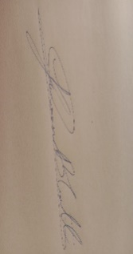

**Signature of External Guide Signature of Internal Guide**

Student Id: 22AIML12

Student Name: YASH GAJERA